DNA Extraction Protocol – Quick prep

Squish buffer [store at 4 C, for up to a month (?? not really sure)]
10 mM Tris-HCl, pH 8.2
1 mM EDTA
25 mM NaCl
0.2 mg/mL proteinase K*

*We use this one from NEB

For 1 mL squish buffer:
2 uL 0.5 M EDTA
10 uL 1M Tris-HCl pH 8.2
5 uL 5M NaCl
10 uL 20 mg/mL proteinase K
973 uL water

1. Remove one leg and place in PCR tube, on ice. Rinse dissection scissors in ethanol between individuals.

2. Add 50 uL* squish buffer to each PCR tube and squish the leg for 5-10 seconds with the pipette tip.

3. Incubate samples at 37 C for 30 min, followed by 95 C for 2 min to inactivate the proteinase K

4. Use 1 uL of sample per 50 uL PCR reaction.

*Volume used can vary. I have used 25 uL, then after step 3, add 25 uL water to dilute and use 1 uL in a 25 uL reaction.

Heteroduplex mobility assay

This protocol follows the methods of Bhattacharya and Van Meir (2019) Scientific Reports 9(4437). doi: 10.1038/s41598-019-39950-4.

1. Using protocol for DNA Extraction – Quick prep, extract DNA – can use a single leg if insect is large like Oncopeltus, or whole animal in the case of Drosophila.

2. Make PCR master mix. Divide master mix between tubes and add 1 uL template. For example:

1X 64X 64X+10%
DNA extract 1 uL -- --
10X Taq buffer 1.25 80 88
dNTPs 0.25 16 17.6
F primer 0.25 16 17.6
R primer 0.25 16 17.6
Taq pol 0.075 4.8 5.28
water 9.425 603.2 663.5
total 12.5

3. If using heterozygous samples, you can run your PCR products immediately. Otherwise, mix the PCR product with an equal amount of PCR product amplified from a wild type sample and form heteroduplexes by denaturing PCR products and reannealing. The program recommended by IDT’s Surveyor kit is:
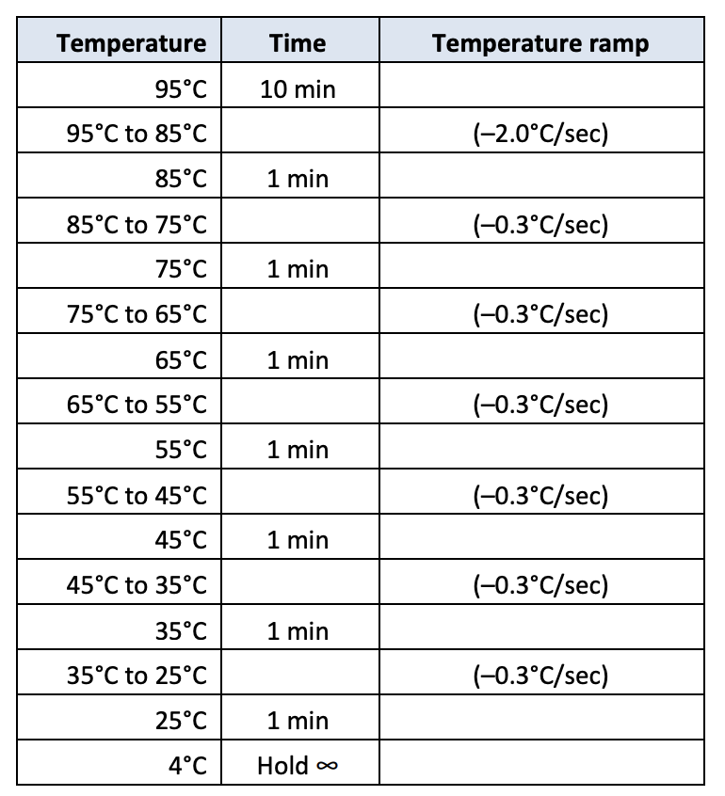

4. Make a 4-6% agarose gel. Run 10 uL each PCR product at 80V for 6 h or more, or 35V overnight, in cold room if possible.

Example result: Here, the first 4 lanes are from homozygous samples. The next four lanes are heterozygous samples, as slower heteroduplex bands are apparent above the band of expected size. The next four are homozygous, and the four following that are heterozygous, but likely a different mutant allele than the previous heterozygotes, as the banding pattern is different. The banding pattern alone should not be used to differentiate alleles, but it’s usually helpful as the heteroduplexes formed by a given WT and mutant allele tend to produce consistent banding patterns.

